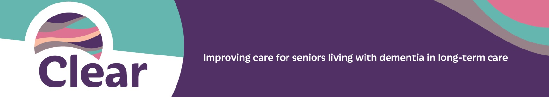

Dear Dr. NAME,

Thank you for taking the time to read this letter and for the care that you provide to your residents.

We are one of 45 care homes across BC participating in a quality improvement initiative called Clear. Clear aims to improve dignity for seniors with cognitive impairment in long-term care homes by providing best practice support to address the behavioural and psychological symptoms of dementia (BPSD), leading to a reduction in the use of antipsychotics for this population.

This third wave of Clear builds upon previous work when the initiative was named the Call for Less Antipsychotics in Residential Care. In Wave 2, 68% of residents with a diagnosis of dementia in 40 care homes (1,001 people) had their antipsychotics reduced or discontinued – a statistically-significant result compared to non-participating care homes.

Clear is led by the BC Patient Safety & Quality Council and supported by a Faculty that includes clinical experts in seniors care and dementia. Our care home will have the support of a Clear improvement advisor until the end of the initiative in April 2019.

We will contact you if we think your resident will benefit from being involved in Clear. When that happens we hope you’ll help us to:
- Clarify the purpose of the prescribed antipsychotic for the resident;
- Begin to taper the antipsychotic, once the initial target symptom has improved and the resident is clinically stable; and
- Carry out our care plan, which includes non-pharmacologic interventions to address BPSD.

We will provide you with:
- Resources developed by practicing geriatric psychiatrists and family doctors to help with any questions you have about discontinuation of antipsychotics.
- Invitations for medication reviews focusing on antipsychotic use in your residents with a dementia and BPSD.

Working together, we can replicate the results of previous Clear waves, including:
- Reducing or discontinuing antipsychotics in residents with BPSD.
- Building knowledge and skills that staff can use during care planning, in particular around using non-pharmacologic approaches to manage responsive behaviours.
- Reducing possible antipsychotic side effects such as drowsiness, cognitive impairment, and extrapyramidal symptoms.

This initiative fits well with the recent Meaningful Medication Review expectation in the GPSC Residential Care Initiative. If you would like to learn more about Clear, please visit www.ClearBC.ca or review a commissioned final report from the second Wave.

For any questions regarding Clear or how you can be more involved, please contact us.

Sincerely,
TEAM NAME(S)

